**Answers:**

1. **Installation of VS Code:**

**Download VS Code:** Visit the official VS Code download page at <https://code.visualstudio.com/download>.

**Choose the appropriate installer**: Select the "Windows" download option (typically a .exe file).

**Run the installer:** Double-click the downloaded .exe file and follow the on-screen instructions. It's recommended to keep the default installation options unless you have specific requirements.

**Launch VS Code**: Once the installation is complete, you can launch VS Code from your Start menu or by double-clicking the VS Code icon on your desktop (if created during installation).

1. **First-time Setup:**

**Settings:** Access the Settings menu by going to "File" -> "Preferences" -> "Settings" (or use the keyboard shortcut Ctrl +,). Here you can customize various aspects of VS Code, including:

**Theme:** Choose a theme that suits your preference for light or dark mode (e.g., Dark+ Default theme).

**Font Size:** Adjust the font size for better readability (Settings > Editor > Font Size).

**Extensions:** Explore the Extensions view (explained later) to install extensions that enhance functionality for specific programming languages or tasks. Some popular choices for web development include:

* + **HTML Tools:** Improves HTML editing experience.
  + **Live Server:** Enables live preview of web pages during development.
  + **ESLint:** Provides code linting and static analysis for JavaScript.

**Welcome Tour:** Consider going through the optional "Welcome Tour" offered by VS Code upon first launch. This tour provides a basic introduction to the user interface and functionalities.

1. **User Interface Overview:**

VS Code's interface consists of several key components:

* **Activity Bar:** Located on the leftmost side by default, it provides quick access to various functionalities like managing open folders, debugging tools, extensions, and the integrated terminal.
* **Side Bar:** This collapsible bar can house different views depending on the current context. It can display the File Explorer for navigating project folders, the Search view for finding text within files, or the Source Control view for managing Git repositories.
* **Editor Group:** This is the central area where you write and edit your code. You can have multiple files open simultaneously, arranged in tabs within the Editor Group.
* **Status Bar:** Located at the bottom of the window, it displays information about the current file (e.g., language, line number), indentation settings, and any warnings or errors.

1. **Command Palette:**

The Command Palette acts as a centralized hub for launching various VS Code features and functionalities. You can access it by pressing Ctrl+Shift+P (Windows/Linux) or Cmd+Shift+P (macOS). It allows you to search for and execute specific commands within VS Code. Here are some examples:

* Open a new file: Type "New File" and press Enter.
* Search for specific settings: Type "settings" and choose the relevant option to modify settings.
* Install extensions: Type "Extensions: Install Extension" and search for the desired extension.

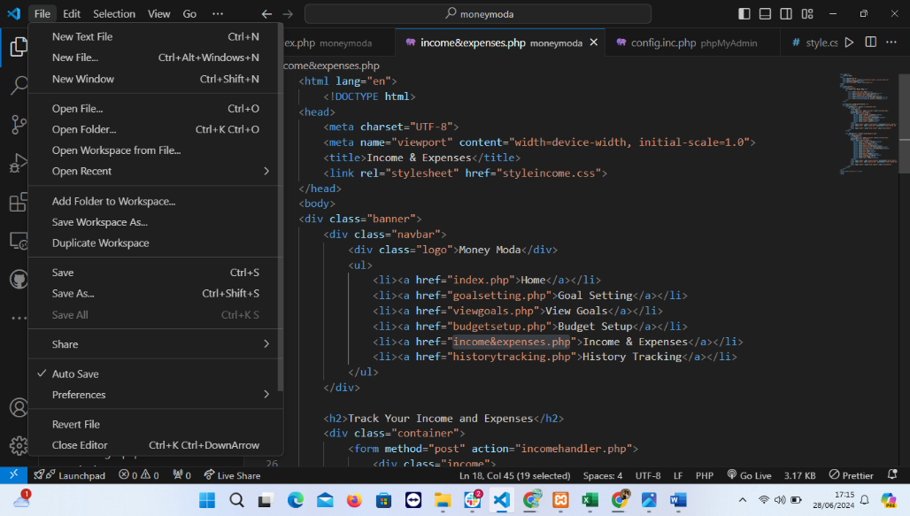

1. **Extensions in VS Code:**

Extensions are add-on functionalities that extend the capabilities of VS Code. They can provide language support, code completion, debugging tools, linters, and many more features.

* **Finding Extensions:** Access the Extensions view from the Activity Bar. You can browse popular extensions or search for specific functionalities.
* **Installing Extensions:** Click the "Install" button next to the desired extension. Once installed, the extension will be integrated into VS Code.
* **Managing Extensions:** The Extensions view allows you to manage installed extensions, including disabling, updating, or reinstalling them.
* **Essential Extensions for Web Development:** As mentioned earlier, some popular extensions for web development include HTML Tools, Live Server, and ESLint. Many other extensions cater to specific frameworks or languages.

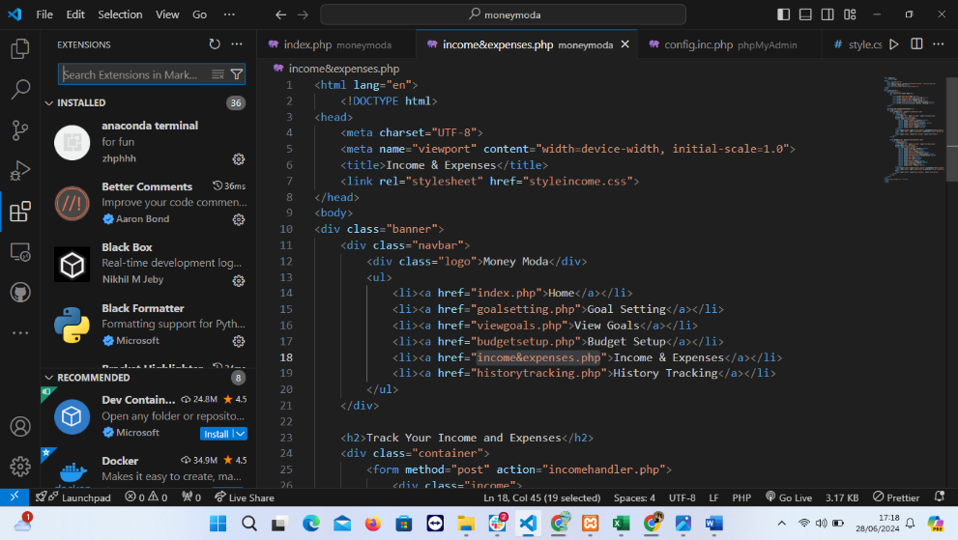

1. **Integrated Terminal:**

The integrated terminal provides a command-line interface directly within VS Code. You can access it by going to "Terminal" -> "New Terminal" (or use the keyboard shortcut Ctrl+ (backtick) on Windows/Linux or Cmd+ (backtick) on macOS).

**Advantages of using the integrated terminal:**

* **Convenience:** It eliminates the need to switch between VS Code and a separate terminal window.
* **Integration:** The terminal can be linked to the current project and debugging sessions within VS Code.
* **Customization:** You can customize the terminal's appearance and behavior through settings.

1. **File and Folder Management:**
2. **Creating Files and Folders:**
   * Right-click in the Explorer view and select New File or New Folder.
   * Use the Command Palette (Ctrl+Shift+P) and type File: New File.
3. **Opening Files and Folders:**
   * Drag and drop files/folders into the editor.
   * Use File > Open File or File > Open Folder.
4. **Managing Files:**
   * Rename, delete, or move files/folders via the context menu in the Explorer view.

**Navigating Between Files and Directories Efficiently:**

* Use Ctrl+P to quickly open files by typing their names.
* Use Ctrl+Tab to switch between recently opened files.
* Use breadcrumbs (enabled via View > Show Breadcrumbs) to navigate the file structure.

1. **Settings and Preferences:**

**Where to Find and Customize Settings:**

* Open settings via File > Preferences > Settings or press Ctrl+,
* Settings are divided into User and Workspace settings.

**Examples of Customizing Settings:**

1. **Changing the Theme:**
   * Go to File > Preferences > Color Theme.
   * Select a theme from the list or install new themes from the Extensions Marketplace.
2. **Changing Font Size:**
   * In the Settings search bar, type font size.
   * Adjust the Editor: Font Size setting.
3. **Changing Keybindings:**
   * Go to File > Preferences > Keyboard Shortcuts or press Ctrl+K Ctrl+S.
   * Search for a command and modify its keybinding.

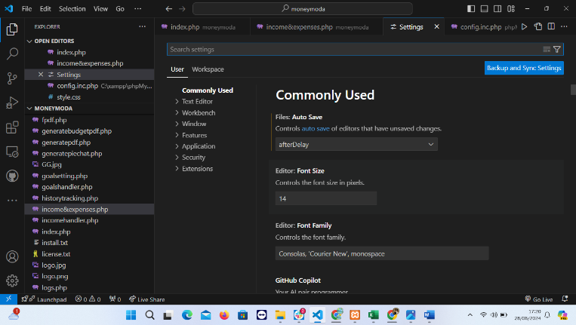

1. **Debugging in VS Code:**
2. **Open the Debug View:**
   * Click on the Run and Debug icon in the Activity Bar or press Ctrl+Shift+D.
3. **Configure the Debugger:**
   * Click on Create a launch.json file to configure the debugger for your project.
   * Select the environment (Node.js, Python, etc.).
4. **Set Breakpoints:**
   * Click in the gutter next to the line numbers to set breakpoints.
5. **Start Debugging:**
   * Click the green play button in the Debug view or press F5.

**Key Debugging Features:**

* Variable inspection
* Call stack navigation
* Watch expressions
* Step over, step into, and step out

1. **Using Source Control:**

**Integrating Git with VS Code:**

1. **Initialize a Repository:**
   * Open the Source Control view by clicking the Source Control icon in the Activity Bar or pressing Ctrl+Shift+G.
   * Click on Initialize Repository.
2. **Making Commits:**
   * Stage changes by clicking the + next to the files in the Source Control view.
   * Write a commit message and click the checkmark to commit the changes.
3. **Pushing Changes to GitHub:**
   * Ensure your repository is connected to a GitHub remote.
   * Use the Command Palette (Ctrl+Shift+P) and type Git: Add Remote to add a GitHub repository.
   * Use the Sync Changes button in the Status Bar to push changes to GitHub.

By following these steps and utilizing these features, you can effectively install, configure, and navigate Visual Studio Code for a productive coding experience.